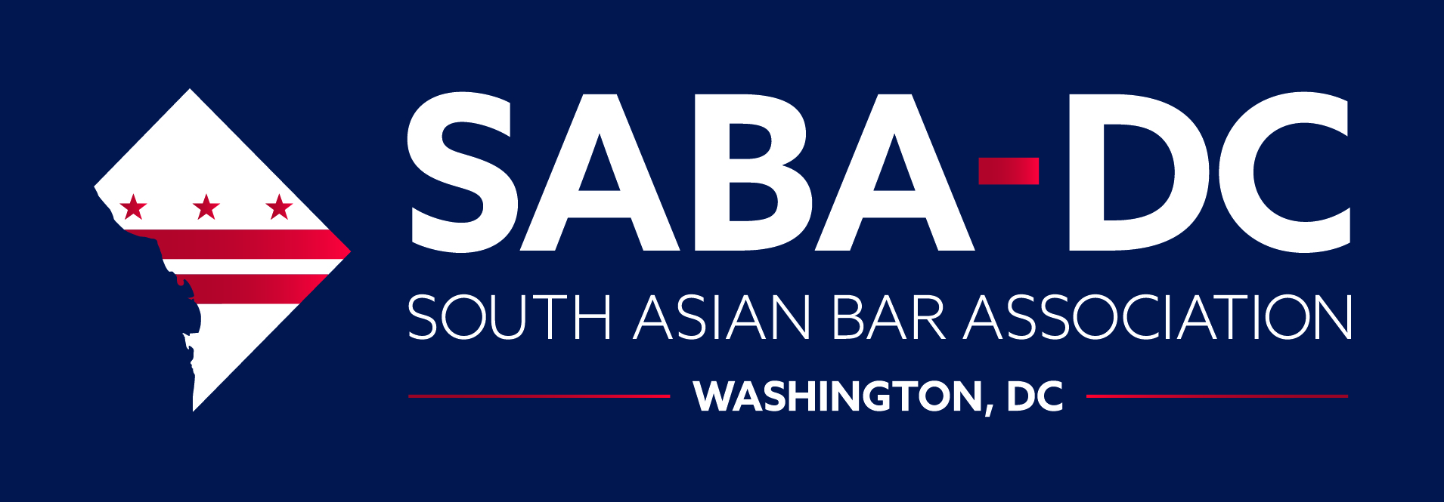
2021 Racial Justice Grant Application

The South Asian Bar Association of Washington, D.C. (SABA-DC) strives to 1) address the needs and goals of South Asian and South Asian American attorneys in the Washington, D.C. metropolitan area; 2) serve as a communication and support network for South Asian and South Asian American law students in the D.C. metropolitan area; 3) represent the interests of South Asians and South Asian Americans at local and national levels; and 4) promote and articulate the unique needs and issues facing the South Asian and other minority communities.

As part of this mission, SABA-DC is committed to advancing racial equity by finding areas where we, as an affinity bar association, can best direct our resources and efforts to effect meaningful change in societal systems and structures that perpetuate racism and discrimination against minority populations. SABA-DC is proud to announce our inaugural Racial Justice Grant, which will invest in concerted efforts that advance racial equity. SABA-DC invites eligible organizations and individuals (see below) to apply for its Racial Justice Grant by submitting proposals for innovative and effective projects and initiatives that address racism in the metropolitan D.C. area. The purpose of this funding is to encourage, empower, and engage social justice and racial equity initiatives by funding projects that benefit the metropolitan D.C. area focusing on a range of issues including, but not limited to: education; community building; access to justice; and combating hate crimes, discrimination, and racial profiling.

About the SABA-DC Racial Justice Grant
SABA-DC will provide an annual grant to an organization, initiative, or project in the metropolitan D.C. area that advances racial justice.

Grant Selection Criteria
- To be eligible for funding, the organization must be principally and physically located in the metropolitan D.C. area.
- Non-profit and community-based organizations are eligible to apply as a primary applicant.
- Individuals launching initiatives or research projects are eligible to apply as a primary applicant.
- Governments, public schools, public colleges, and public universities cannot be a primary applicant. Organizations or initiatives associated or affiliated with a government, public school, public college, or public university may apply as a primary applicant (e.g., a student organization, a parent-teacher association, an individual affiliated with the institution).
- The Racial Justice Grant provides funding to recipients whose organizational projects meet one or more of the following goals:
- Provide opportunities, such as workshops or training, to understand and unlearn racism, effectively act or advocate to address racism, and understand the intersectional dynamics of oppression.
- Broaden the conversation on how to combat racism and further racial equity.
- Strengthen the local community culture of inclusion and belonging.
- Seek to eliminate an inequity in the community (individual, institutional, or structural), thereby assisting individuals or groups that have been marginalized in the metropolitan D.C. area.

Grant Application Process
The primary purpose of the grant is to strengthen the community culture of inclusion, belonging, and equality in the metropolitan D.C. area. The grant amount and recipient will be determined by the SABA-DC Racial Justice Committee and is based on SABA-DC’s fundraising efforts and the number of quality applicants it receives.

Deadline
Applications must be submitted by June 30, 2021. The Racial Justice Grant Committee will review each complete application submitted and will make a final decision no later than August 31, 2021, with funding distributed shortly thereafter.

SABA-DC Non-Discrimination Policy
It is the policy of SABA-DC not to discriminate on the basis of age, gender, disability, race, color, creed, religion, ethnicity, national origin, veteran status, or sexual orientation. All potential applicants are encouraged to apply.

SABA-DC Racial Justice Grant Application

1. Contact Information
Organization Name:
Email Address:
Mailing Address:
Telephone Number:
Website:
Name of Contact Person:
Title:
Email Address:
Telephone Number:

2. Organization Applicant
What is the Organization’s mission?
How long has the Organization been in operation?
Include proof of Organization’s non-proft status?
Provide an example of a project initiated by the Organization in the last three years that had a wide community reach and impact, and the current status of this project. If the Organization is newly established, provide an experience with a prior organization that inspired this proposal.

3. Proposal
To what program, service, or activity will the SABA-DC Racial Justice Grant be applied?

Is this an ongoing program, service, or activity? If so, how long has this program, service, or activity been in effect? Provide a narrative of how this ongoing program, service, or activity was initiated.

How does the program, service, or activity advance racial justice? Be specific.

What community need does this program, service, or activity fulfill? Response should include information or data that demonstrates the need (including the projected demographics of community members that will be served by the program, service, or activity including age, race, gender, and income level).

What output will the Organization produce as a part of the program, service, or activity that can be shared with others in the community to eliminate racial and social inequities (e.g., processes, tools, reports, etc.)?

Does the program, service, or activity include partnerships or collaborations with other organization(s)? If so, which organization(s)? Provide a detailed description of the partnership/collaboration, including the duration of the partnership/collaboration for a SABA-DC Racial Justice Grant.

4. Amount of Funding Requested:

How will the funding be used?

Will the program, service, or activity be continued or expanded after the SABA-DC Racial Justice Grant ends? If so, how? The sustainability plan should be specific on future funding and not simply state the organization will continue to look for support.

5. Please identify below all other grants, scholarships, or other sources of funding for which you have applied and/or will be receiving during the period for which you seek a SABA-DC Racial Justice Grant (attach a supplemental sheet if needed). For status of application, please indicate whether it is pending or granted.
Grant/Scholarship/Source of Funding | Status of Application | Award Amount

I, the undersigned applicant, certify that all statements and information contained herein and in all application materials are true, correct and accurate to the best of my knowledge.
Print Name of Applicant Signature of Applicant Date
APPLICATION MATERIALS MUST BE E-MAILED NO LATER THAN JUNE 30, 2021 TO SABADCRacialJustice@gmail.com.
SABA-DC Racial Justice Grant Application

“Organization” includes any qualified applicant under the grant selection criteria.

